Week 2 – Java and Spring Assignment – Ette Divya Nikitha
- 1.List the features of Java 8
- Lambda Expressions.
- Functional Interfaces
- Stream API
- Default methods in interfaces
- New Date and Time API
- Method References
- What is a Lambda Expression, and why do we use them? Explain with a coding example and share the output screenshot
A Lambda Expression is a way to represent an anonymous function.It allows you to pass behavior as an argument to methods.It Reduces boilerplate code,Makes code more readable and Helps with functional programming in Java.
(parameters) -> { body }
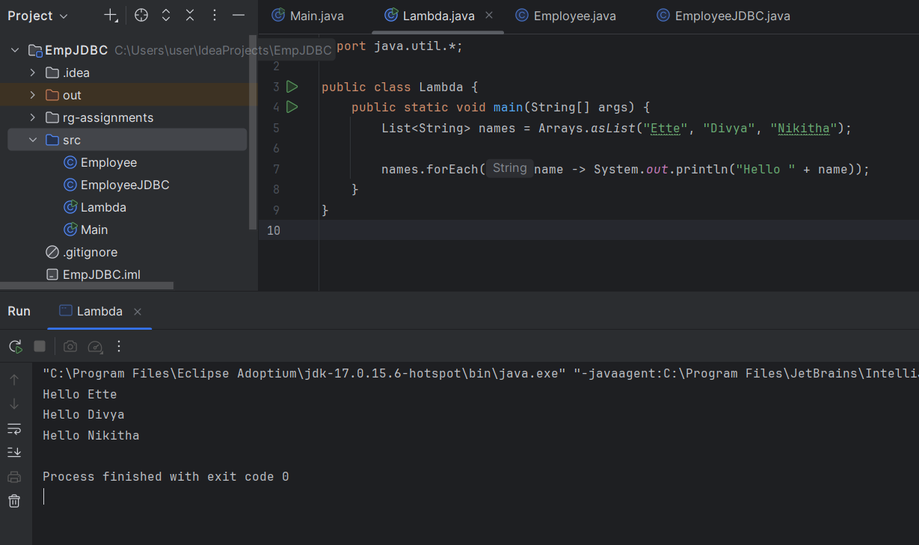

- What is optional, and what is it best used for? Explain with a coding example and share the output screenshot.
Optional is a container class to handle null values safely.
It helps avoid NullPointerException.Its Best Use is to Return Optional instead of null from methods and Check presence with isPresent() or orElse().

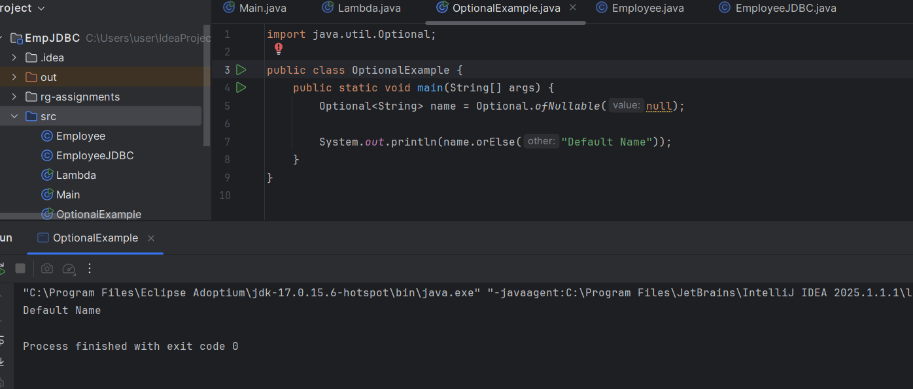

- What is a functional interface? List some examples of predefined functional interfaces.
A Functional Interface is an interface with only one abstract method.Examples of Predefined Functional Interfaces:
- Runnable - | Runs a task
- Callable | Returns a result
- Predicate<T> | Returns boolean
- Function<T,R> | Takes input T, returns R
- Consumer<T> | Performs an action on T
- Supplier<T> | Supplies a value of T

- How are functional interfaces and Lambda Expressions related?
• Lambda expressions implement functional interfaces.
• You can assign a lambda to any functional interface directly.

- List some Java 8 Date and Time API’s. How will you get the current date and time using Java 8 Date and Time API? Write the implementation and share the output screenshot.

Some Java8 Date and Time APIClasses:
- LocalDate
- LocalTime
- LocalDateTime
- ZonedDateTime
- Duration
- Period
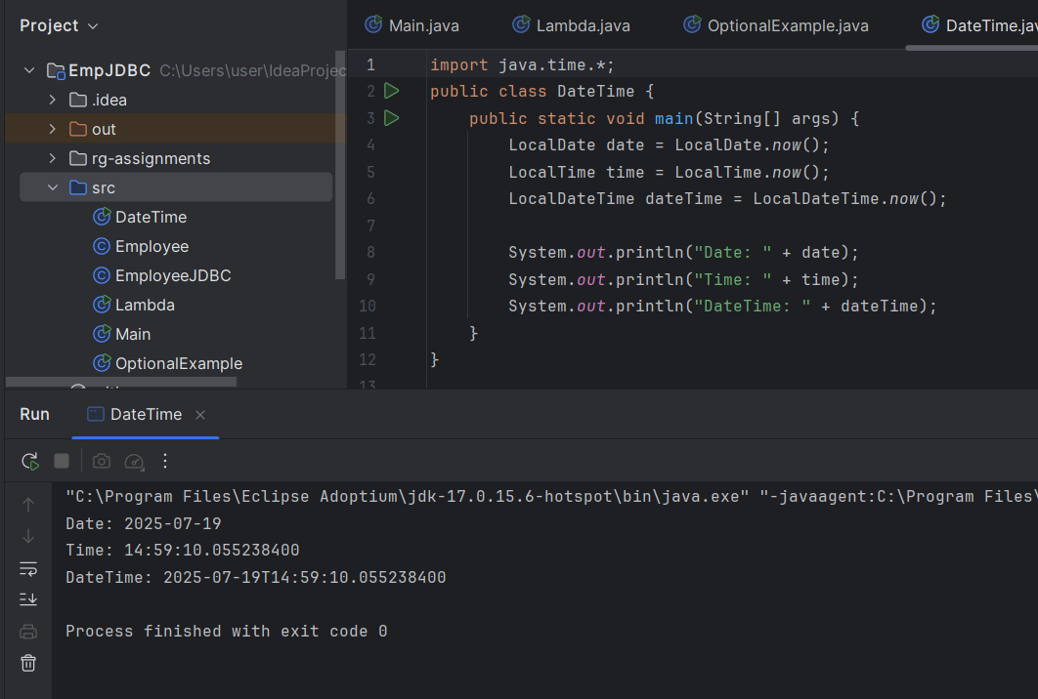

- How to use map to convert objects into Uppercase in Java 8? Write the implementation and share the output screenshot.
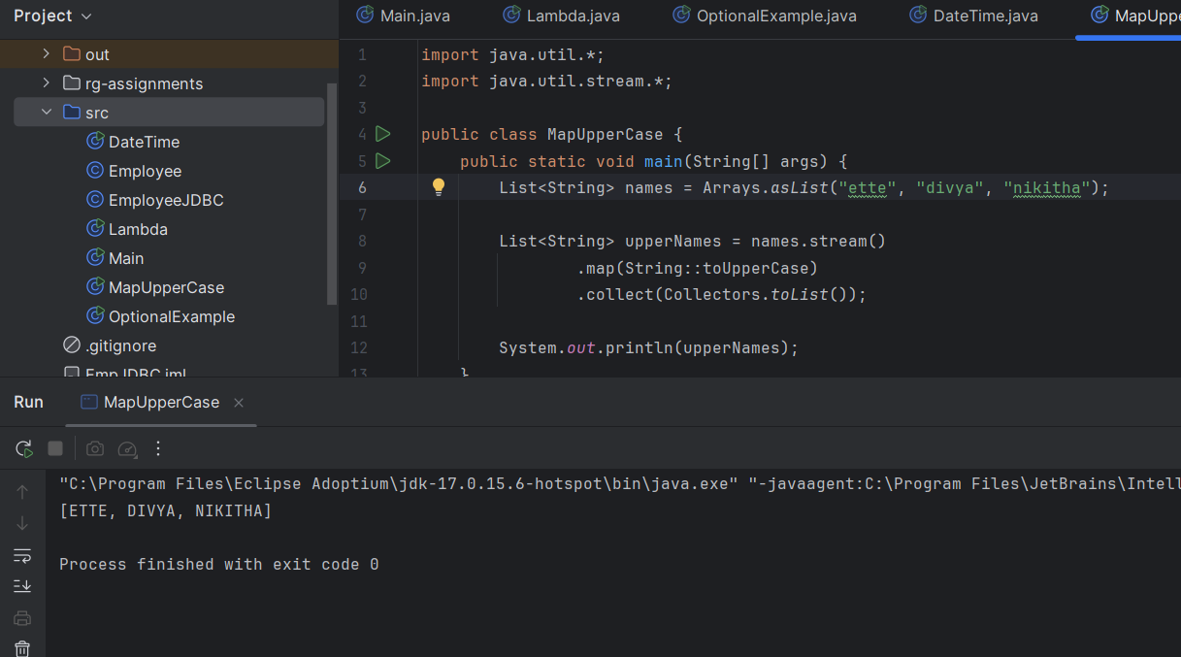
- Explain how Java 8 has enhanced interface functionality with default and static methods. Why were these features introduced, explain with a coding example?

To add new features to interfaces without breaking existing implementation
Suppose you have an interface:
interface Animal {
void eat();
}
If you add a new method like sleep():
interface Animal {
void eat();
void sleep(); // New method added
}
All classes implementing Animal will break, because they are forced to implement sleep().
This makes it hard to evolve interfaces in large applications or public APIs (like Java collections, etc.).
Java 8 introduced default methods to allow method implementations inside interfaces.
interface Animal {
void eat();

default void sleep() {
System.out.println("Animal is sleeping");
}
}
Now, if you add sleep() as a default method, existing classes won’t break.
They will automatically inherit the default behavior unless they choose to override it.

- Discuss the significance of the Stream API introduced in Java 8 for data processing. How does it improve application performance and developer productivity?

Before Java 8, processing collections involved external iteration using loops, which made code verbose, error-prone, and harder to parallelize. The Stream API introduced internal iteration and a declarative programming model, making data processing easier, cleaner, and more efficient.

You focus on what to do (filter, map, reduce) rather than how to do it (loops, iterators).

Reduces code size by eliminating for-loops and conditional checks.

Supports method chaining, making code readable and concise.

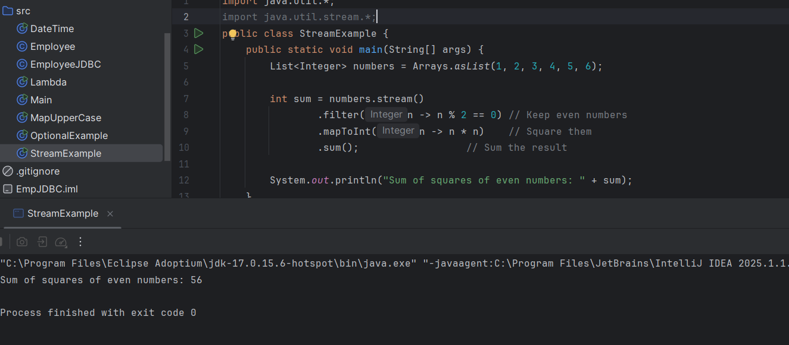
- What are method references in Java 8, and how do they complement the use of lambda expressions? Provide an example where a method reference is more suitable than a lambda expression. Explain with a coding example and share the output screenshot.
A method reference is a shorthand notation of a lambda expression that calls an existing method.

Syntax: ClassName::methodName

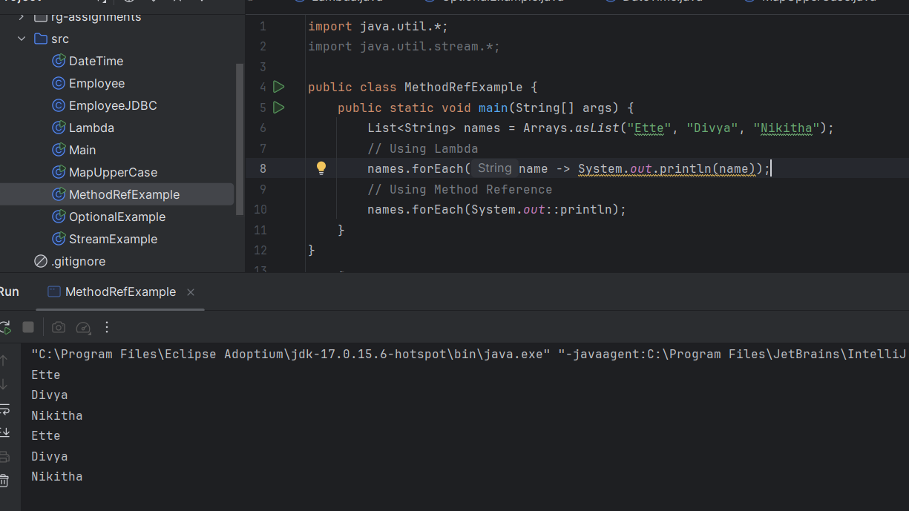

Maven, Spring and Spring Boot
- Install maven 3.6 or above. Execute mvn -v in the local terminal/command prompt and share the screenshot
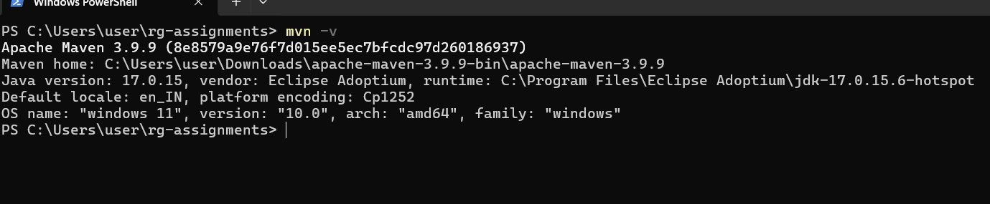
- What is the difference between maven central repository and local repository?
Local Repository | Central Repository
Resides on your local machine | Hosted on the Internet
Location: ~/.m2/repository (default) | URL: https://repo.maven.apache.org/maven2
Stores previously downloaded jars | Official Maven repository for open-source dependencies
Faster builds (no re-download needed) | Downloaded when dependency is not found locally

- Maven commands
  - To build the maven project – mvn clean install
  - To run the maven tests – mvn test

- Please locate the maven settings.xml file and local maven repository in your machine and share the screenshot

- The basic principle behind Dependency Injection(DI) is that the objects define their dependencies .What are the different ways in which an object can define its dependency ?
Constructor Injection | Pass dependencies via constructor

Setter Injection | Use setter methods to inject dependencies

Field Injection | Use annotations directly on fields

- What is the difference between the @Autowired and @Inject annotation?
Both perform dependency injection, but @Autowired is Spring-provided, while @Inject is Java standard.

- Explain the use of @Respository, @Component, @Service and @Controller annotations with an example for each.
@Component | Generic bean (utility/helper classes)

@Service | Business logic (service layer)

@Repository | Data Access Object (DAO layer)

@Controller | Web layer (handle HTTP requests)

- Fix the code and explain why?
The following code tries to inject a property from application.properties, but the appName field is always null. Identify and fix the issue.

@Component
public class AppNamePrinter {

@Value("app.name")
private String appName;

public void printAppName() {
System.out.println("Application Name: " + appName);
}
}

@Value("app.name") is injecting the literal string "app.name", not the property value from application.properties, need to use ${} syntax to tell Spring to resolve it as a property.

- What does the @SpringBootApplication annotation do?
@SpringBootApplication is a convenience annotation in Spring Boot.
It combines 3 important annotations into one:
@Configuration | Marks the class as a Spring configuration
@EnableAutoConfiguration | Tells Spring Boot to automatically configure beans based on classpath dependencies.
@ComponentScan | Automatically scans for @Component, @Service, @Repository, and @Controller in the current package and sub-packages.

- What is the maven command to start the SpringBootApplication?
mvn spring-boot:run

- Implement EmployeeCRUD using Spring and JDBC with the below Employee class. In the branch feature-spring, create a folder Employee-Spring. Push the solution to the branch and share the link.
class Employee{
private int id;
private String name;
private String department;
}
https://github.com/divyaette/rg-assignments/tree/feature-spring
- Implement EmployeeCRUD using SpringBoot and Spring Data JPA with the below Employee class. In the branch feature-spring, create a folder Employee-SpringBoot-JPA. Push the solution to the branch and share the link.

class Employee{
private int id;
private String name;
private String department;
}

https://github.com/divyaette/rg-assignments/tree/feature-spring

- Follow the demo in the pre-work link https://www.youtube.com/watch?v=hr2XTbKSdAQ&t=18s and create a Spring Batch application that processes customer data. In the branch feature-spring, create a folder Customer-SpringBatch. Push the solution to the branch and share the link.

https://github.com/divyaette/rg-assignments/tree/feature-spring

